
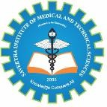
SIMATS ENGINEERING
Saveetha Institute of Medical and Technical Sciences Chennai- 602105

Student Name: Hariprasath M Reg. No.: 192421246
Course Code: CSA1522 Slot: C
Course Name: Cloud Computing & Big Data Analytics
Course Faculty: Dr. Rajaram P

Project Title: Cross-Platform Cloud Storage Access and Synchronization System
Module Photographs:
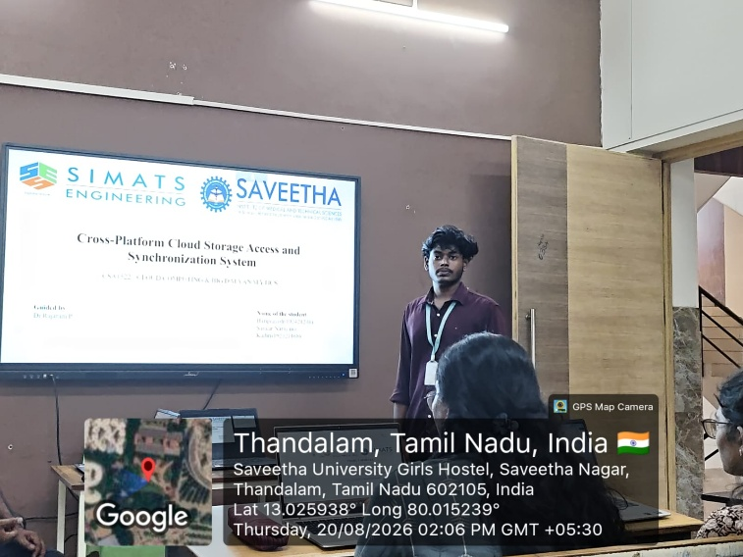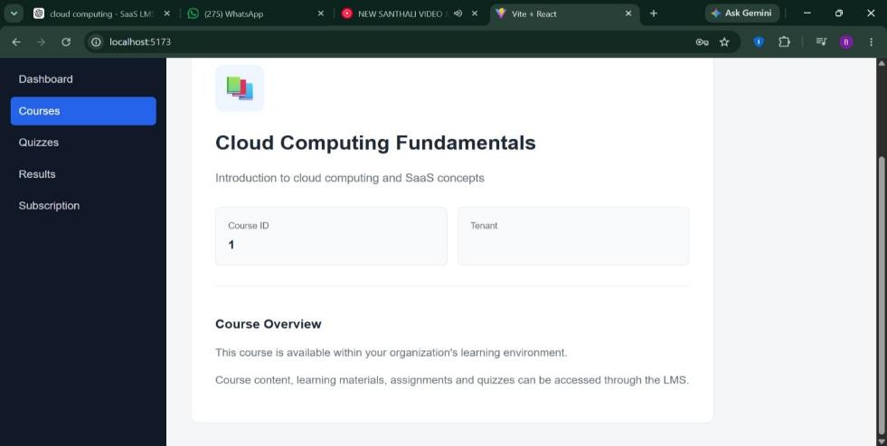
Project Description:
My contribution to this project is the complete system covering all three modules. Module 1, Cross-Platform Client & Authentication, provides native client apps for desktop and mobile so users get a consistent experience across Windows, macOS, Linux, Android, and iOS. I implemented user registration, login, and secure token-based authentication, along with device linking and an offline access mode for viewing files without an internet connection. Module 2, Storage & Synchronization Engine, detects file changes on any device and propagates updates in real time using delta synchronization to reduce bandwidth usage. It includes conflict detection and resolution, file versioning, selective sync, and background sync scheduling. Module 3, Cloud Storage & Security Management, hosts user data on a scalable cloud backend, secured through end-to-end encryption, access control, and file-sharing permissions, with storage quota management, automatic backup, and usage monitoring. Overall, my contribution focuses on secure authentication, real-time synchronization, and reliable, encrypted cloud storage across every platform.

Student Signature Guide Signature

